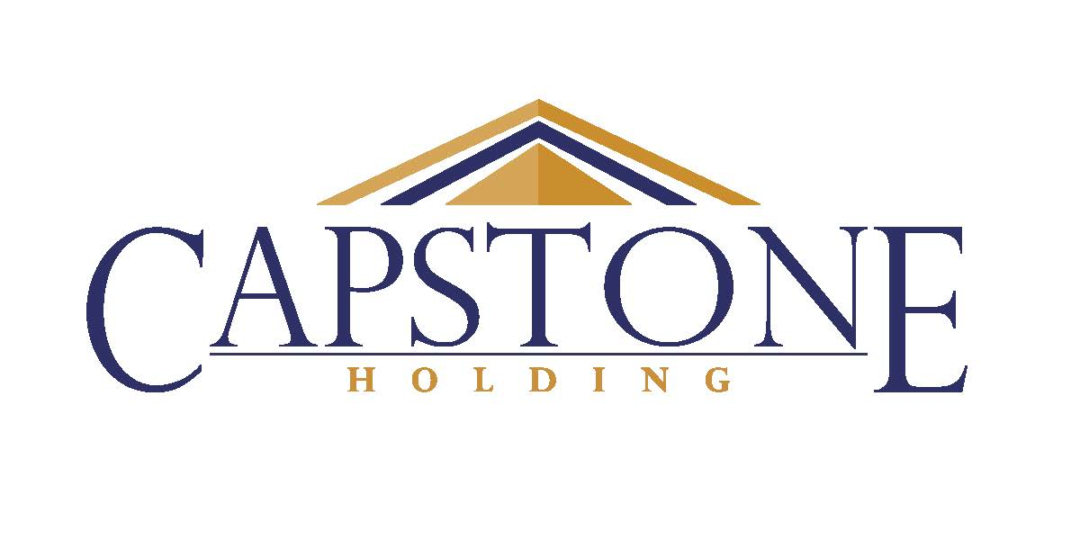
5141 W 122nd Street
Alsip, IL 60803
(708)371-0660
www.capstonethx.com
OTCQB: CAPS
FOR FURTHER INFORMATION:
Investor Relations
(708)371-0660
investorinquiries@capstonethx.com

CAPSTONE HOLDING CORP. ANNOUNCES EXERCISE OF SECURED DEBT AND INTEREST CONVERSION OPTION BY MAJORITY SHAREHOLDER, BP PEPTIDES, LLC

Alsip, IL – June 21, 2022 ─ Capstone Holding Corp. (OTCQB: CAPS) (“the Company”)

EXERCISE OF SECURED DEBT AND INTEREST CONVERSION OPTION; ISSUANCE OF 78,333 SHARES OF THE COMPANY’S COMMON STOCK

On June 15, 2022, BP Peptides, LLC (“Brookstone”) exercised its right to convert $1,938,746 of accrued interest and debt from its Senior Secured Note(s) into 78,333 shares of the Company’s Common Stock (exercise price of $24.75/share). With this acquisition Brookstone now owns 121,774 shares of the Company’s Common Stock or 77.26% of the 157,610 outstanding shares of the Company’s Common Stock.

Please see the Company’s 2021 Annual Report filed with the OTCQB Markets for further information.

About Capstone Holding Corp.
Capstone Therapeutics (now Capstone Holding Corp.) was a biotechnology company committed to developing novel therapeutic peptides aimed at helping patients with under-served medical conditions. The drug development business has been discontinued. The Company’s primary business activity going forward will be the operations of TotalStone, LLC, a construction materials company, and managing its equity interest in Diamond Products, LLC through its ownership of Capstone Beta, LLC, a member of Diamond Products Holdings, LLC.

Capstone’s corporate headquarters is located in Alsip, Illinois. For more information, please visit the Company's website: www.capstonethx.com.

Statements in this press release or otherwise attributable to Capstone regarding our business that are not historical facts are made pursuant to the safe harbor provisions of the Private Securities Litigation Reform Act of 1995. These forward-looking statements involve risks and uncertainties that could cause actual results to differ materially from predicted results. These risks include the factors discussed in our Annual Report for the fiscal year ended December 31, 2021, and other documents we filed with the U.S. Securities and Exchange Commission or OTCQB Markets.

